ava dIRECTORY
2014
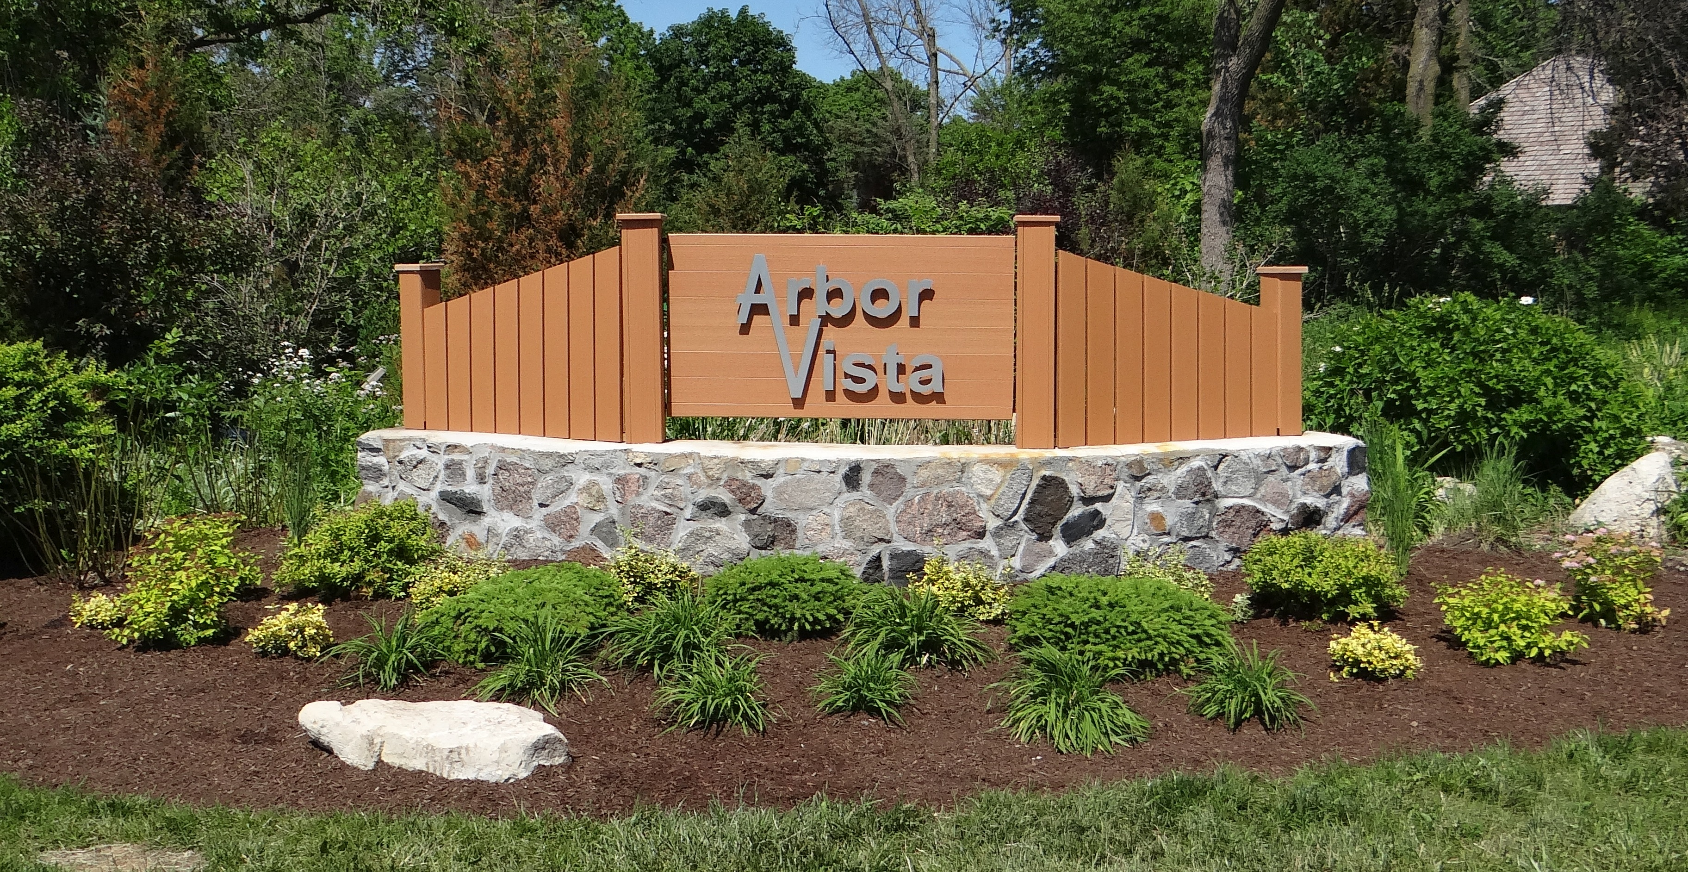

For information in and around our area go to:

ARBORVISTA.ORG

Check out the social network available

only to households in AVA. There is no charge to you or the association for this site.

arborvista.nextdoor.com

Association dues are currently $50 per year, payable each January to:

Treasurer, Arbor Vista Association P.O. Box 433 Grayslake, IL 60030

Arbor Vista Association Officers 2014

President Joe Trasatti 223-8099
Hav7878@hotmail.com

Vice President Sue Godsey 752-8755
swgodsey@gmail.com

Secretary Lisa Crowley 445-0163
lisa_crowley@att.net

Treasurer JB Morrow 223-6775
jbjudy@ameritech.net

Welcoming JoAnn Lamb 223-0502
LambD@MSN.com

Neighborhood Watch Karen Hoppel 548-0522
KarHoppel@gmail.com

Social Co-Chair
Easter Jennifer Kielp 910-9183
jennifer@nounces.com
Car Show & Picnic Mike Holbach 793-7224
Mike.Holbach@grainger.com
Fall Halloween Jackie Lipinski 223-0339
Jackiexxx@xxx

Adopt A Highway Karen Hoppel 548-0522
KarHoppel@gmail.com

Building & Grounds Rick Hoppel 548-0522
rhoppel@gmail.com

Sergeant at Arms Karen Hoppel 548-0522
KarHoppel@gmail.com

Please report any directory changes / corrections to JB Morrow 223-6775
jbjudy@ameritech.net

This current copy of the AVA Homeowner Directory Is being distributed to all addresses. This is a courtesy copy to those of you who have forgotten or chose not to be a dues paying member. We hope that this acts as another reason to return or become an active dues paying household.

The current dues are $50 per year (less than a dollar a week). That money provides not only these directories, the front entrance upgrade & maintenance, but other activities that help us to take pride in our subdivision.

Please see inside for more information about dues usage and a list of households in good standing that make these items possible.

In the future, as previously, these directories will only be sent to those households that are in good standing, defined as: THE DUES HAVING BEEN PAID FOR THE CURRENT AND PREVIOUS YEAR.

If you have questions, comments, concerrns or suggestions, please contact any board member.

All Emergencies – 911

Which Law Enforcement Agency has jurisdiction in the areas within and around Arbor Vista?

Within Arbor Vista
- Unincorporated
- Lake County Sheriff

North of Arbor Vista
- Owned by state government

South of Arbor Vista
Owned by Libertyville Township

East of Arbor Vista
- Owned by Lake County Forest Preserve

Lake County Sheriff
- Emergency 911
- Non emergency 847-549-5200
- Crimestoppers 847-662-2222
- Public Information Office 847-377-4070

Lake County Forest Preserve Ranger
847-968-3411 6AM-3PM Monday-Friday
For non-emergency public safety issues during other hours, please call the Lake County Sheriff's non emergency office at 847-549-5200


OTHER IMPORTANT TELEPHONE NUMBERS

Lake County Sheriff Emergency 9-1-1
Non-Emergency 847-549-5200

Grayslake Fire Department Emergency 9-1-1
(Specify - fire or rescue) Non-Emergency 847-223-2120

Lake County Animal Control - Including Barking Dogs 847-949-9925

Note:
You can call the Sheriff to report a barking dog after hours 847-549-5200

Commonwealth Edison 800-334-7661

JULIE (Utility location) 8-1-1

Lake Country Public Works………. Emergency 847-336-1611
Non-Emergency 847-377-7500

North Shore Gas…………………… Emergency 866-556-6005
Non-Emergency 866-556-6004

Warren-Newport Library 847-244-5150
Remenber to check their web site for bookmobile days & times
http://www.wnpl.info/index.php/bookmobile-schedule/

Warren Township Offices 847-244-1101

Grayslake Post Office 847-223-2787

Waste Management 800-796-9696

What do association dues provide:

Printing & distributing this directory to homeowners in good standing.
Defined as: the dues having been paid for the CURRENT AND PREVIOUS YEAR.

Community events
Easter egg hunt
Summer car show & picnic
Halloween party & chili cook-off

Front entrance
Landscape maintenance & beautification
Electrical system & lighting
Holiday decorations

Community involvement
Tools used in cleaning & rehabilitating the pond area
Legal assistance
Adopt-a-highway equipment
Welcome committee supplies

P.O. Box & other correspondence



