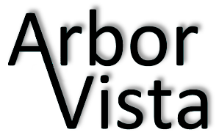

AVA Board Meeting Agenda
Date: Month X, 2016 Time: 6:30 PM
Location: 32438 N. Forest Drive – Hoppel Residence
 | Elected Officers |  |  | Committee
 | President | Karen Hoppel |  | Building & Grounds | Rick Hoppel
 | Treasurer | JB Morrow |  |  | Linda Swarthout
 | Vice President | Joe Trasatti |  | Social | Jennifer Kielp
 | Secretary | Lisa Crowley |  | Welcoming | Joanne Lamb
 | Sergeant at Arms | Sue Godsey |  |  | Paula Glassel

OLD BUSINESS:
- Approve Last Board Meeting Minutes
- Treasurer Report
- Committee Updates
  - Building & Grounds
  - Easter Egg Hunt – Saturday March 26 10 am – Jennifer
  - Arbor Vista Historical Society – Status Update
- Bob Krombach Status Report
- New Signage – Easter Egg Hunt, Halloween – Date on sign, white w/black Joe & Jennifer

NEW BUSINESS:
- Schedule Next Board Meeting

