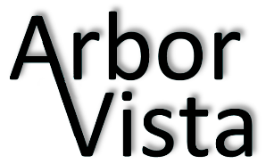

AVA Board Meeting Minutes
Date: March 22, 2016 Time: 6:30 PM
Location: 32438 N. Forest Drive – Hoppel Residence
Board Members Present: Karen Hoppel, Joe Trasatti, JB Morrow, Lisa Crowley, Rick Hoppel, Paula Glassel and Jennifer Kielp.
Meeting came to order at 6:35 PM

OLD BUSINESS:
- Approved last board meeting minutes.
- Approved AVA Homeowners Association meeting minutes.
- Reviewed Committee updates. Jennifer is all set for Easter Egg Hunt. Board will look at option of serving coffee and donuts at next year’s Easter Egg Hunt.
- Audit confirmed for April 5th at 6:30pm at JB Morrow’s house. JB, Sue Godsey, Vic Taylor, Nancy Trasatti and Karen Hoppel will be in attendance.
- Adopt-A-Highway confirmed for Saturday April 23 at 9:00am.
- Additional bench will be added to pond this year.

NEW BUSINESS:
- Joe, Jennifer and Linda will be working together to create a new Halloween sign for front bulletin board.
- Joe and Rick will work on polishing the bulletin board.
- Paula discussed Welcome Letter and suggested some changes to the letter.
- Paula is looking into Welcome gift ideas.
- Next meeting scheduled for June 7th at 6:30pm. Karen Hoppel’s residence.
- Motion to adjourn meeting. Motion seconded and passed.
- Meeting closed at 8:15pm.

